UKMTO
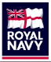
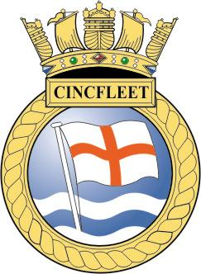

INFORMATION

MERCHANT VESSEL VOLUNTARY REPORTING SCHEME

The UK Royal Navy’s Maritime Trade Organisation (MTO) has been established in the Middle East since late 2001 as an extension of Royal Navy operations in the region. Although the MTO team focus is in support of UK flag and UK interest shipping in the area it is available to provide support across the entire maritime industry including shipping of all flag registry and ownership. The team will remain in the Region for the foreseeable future.

In November 2002 the voluntary reporting scheme for UK interest shipping was extended to cover the Red Sea, Indian Ocean north of 5S as well as the Arabian Gulf. On a voluntary basis only, ships (of any flag or ownership) are invited to report to the Maritime Trade Operations team on passing the following reference points:

a. Suez for vessels entering or leaving the Region via the Red Sea
b. 5S for ships entering or leaving the Region via the Indian Ocean (SOUTH)
c. 78E for ships entering or leaving the Region via the Indian Ocean (EAST)

The initial report should contain the following;
Ship Name
IRCS (International Radio Call Sign)
Flag
IMO number
MMSI
Inmarsat telephone number including satellite prefix
Telex and fax number
Email address
Name of Company having day-to-day management
Type of Ship
Date/time of current position course and speed
Itinerary in the region with route way points and destination port(s)
British personnel onboard (if any)

Subsequently, ships are requested to report their noon positions and speed, actual departure times and estimated arrival times at ports and destination when outward bound from the defined area. All timings are requested in UTC and the preferred method of communication is e-mail.

Contact numbers/details for UKMTO as follows:

E-mail ukmto@eim.ae
Telephone CO +971 50 552 3215
2IC +971 50 552 6007
Fax +971 4 306 5710
Telex (51) 210473

The information provided is treated in strict commercial confidence and is only used within coalition military circles. Royal Navy assets in the region and Northwood Headquarters in UK are kept advised.

If further advice or guidance is required please do not hesitate to contact the UKMTO Team. Alternatively, RFA WAVEKNIGHT is also operating in the region and can be contacted as follows:

E-mail 432-ops@a.dii.mod.uk
Telephone 0044 207 807 8642

